Module 6: Critical Thinking Assignment

Nathan Rogers
Colorado State University Global
Course Code: CSC505
Dr. Luis Gonzalez
03/23/2025

Assignment
Apply a “stepwise refinement approach” to develop three different levels of procedural abstractions for one or more of the following programs:
- Develop a check writer that, given a numeric dollar amount, will print the amount in words normally required on a check.
- Iteratively solve for the roots of a transcendental equation.
- Develop a simple task-scheduling algorithm for an operating system.

Write an algorithm in Python that will represent your stepwise refinement approach for the program of your choice.
Use one of the following UML tools to create your diagrams for this assignment and implement your system in Python
I chose to complete the assignment using program option 1: Develop a check writer. Below is the output of the python script which demonstrates several use cases, number inputs, and error cases. The output is in the standard “Dollars in words and cents/100”. There is also the accompanying UML diagram that outlines an iterative abstraction “stepwise refinement approach”.
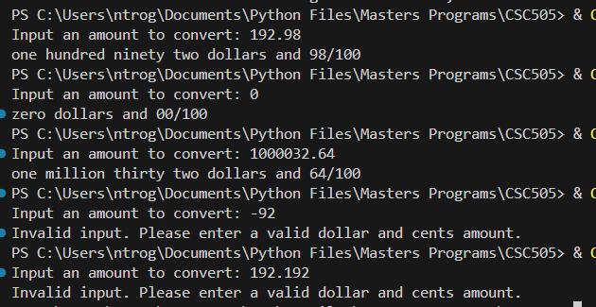

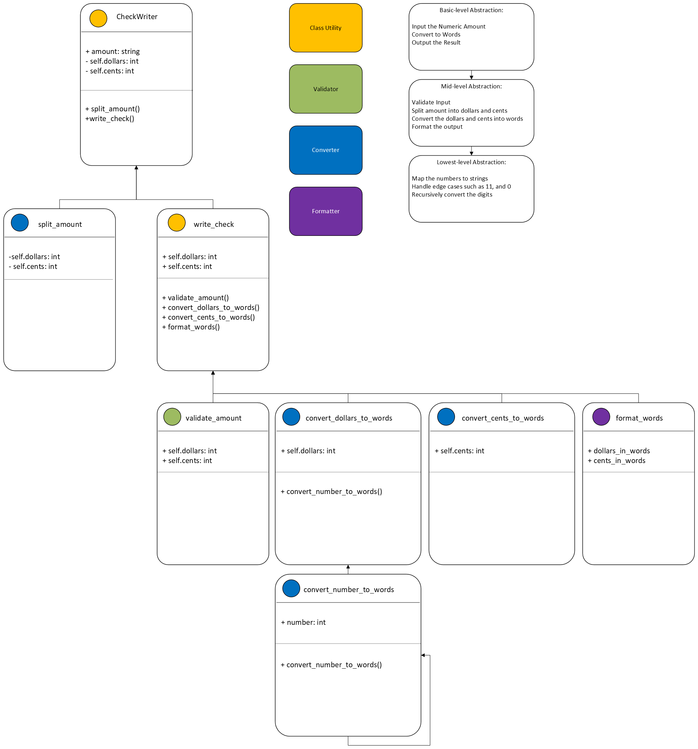

Analysis
In the UML diagram above, it can be observed that there are three layers of iterative abstraction happening. The first layer being the class utility layer, which just houses some helper functions for the class and the class itself. This layer houses the basic abstracted functionality and the simplest representation of the solution. Below that we have the validation layer and mid-level abstraction layer, which validates the incoming data before processing. This is an important layer as we can catch any data coming in that doesn’t fit in the conversion layer and ensures its integrity before processing. Next is the conversion layer. This is the bulk of the program to where the user input is converted from a string of characters into a float and then converted into words representing the input values. The conversion layer is the lowest layer of abstraction as this encompasses specific logic and algorithms on how the solution is computed. Lastly, we the formatter layer or the output layer, which allows the program to output the result back to the user. This layer can fit in both the basic-level abstraction layer and the mid-level abstraction layer because at the basic-level layer we can just say output and in the mid-level layer we can say format output. This shows a separate and iterative level of abstraction on the same functionality.
Abstraction and Iteration
According to Pressman and Maxim, a stepwise refinement approach is defined as, “Successively refining levels of procedural detail is a good way to develop an application. A hierarchy is developed by decomposing a macroscopic statement of function (a procedural abstraction) in a stepwise fashion until programming language statements are reached.” (Pressman & Maxim, n.d.). Abstraction and iterative methodologies are important by themselves, however when combined, they can lead to a well-developed application with a good overall user experience. Let’s first talk about abstraction.
“Objects in an OOP language provide an abstraction that hides the internal implementation details. Similar to the coffee machine in your kitchen, you just need to know which methods of the object are available to call and which input parameters are needed to trigger a specific operation.” (Janssen, 2024). Abstraction exists in almost everything today, from the inner workings of technology, operating systems, appliances, automobiles, etc. Let’s take a deeper look at an appliance, more specifically an oven stovetop. Without the idea of abstraction, the user would have to know how to regulate the gas coming through the nozzle and light the burner all while trying to cook the meal of choice. With the use of abstraction, all the user needs to know is how to set the dial to the desired heat intensity and the rest is done for them. Upon turning the dial, the gas flow and lighter is automatically started for the user. This can be observed in application programming too. A simple button press in an application is a level of abstraction. The button press can enact several function calls and many lines of code for the user to receive an output. The user doesn’t need to know that there are 42 function calls, what those functions are called, that there are 1000 lines of executed code, or how to schedule those lines of code to be executed in the operating system/CPU all to get the same output. All the user needs to know is what the button press will return and how useful that information or functionality is to them. If the user had to know all of the inner workings, then the user experience might not be a good one. Abstraction has a direct link to how good the user experience is.
Iteration is also a very important ideology in program/application development. Iterative development allows for early and constant feedback from stakeholders and users to improve the overall functionality and experience of the program. This is why Agile development is so popular amongst development teams. Agile is a methodology that breaks development up into sprints, which are short spans of development that focus on one or two functions that the user or stakeholders want to see in the software or what the market is directing to. Especially when ChatGPT made its debut, everyone shifted their sprint development to designing and developing their own AI functionality. This allowed companies to stay relevant with the ever-shifting market. The addition of AI made it easier for users to use the software or added new functionality users could take advantage of.
Smaller chucks of code are also much easier to debug and ensure maximum quality is achieved before releasing to users and stakeholders. If larger features are developed and tested there are higher chances for bugs to escape to the end user which would impact the overall user experience.
Drawbacks of Abstraction
Abstraction can definitely improve the user experience; however, too much abstraction can lead to a negative experience. For example, when Microsoft released Windows 11, the right-click context menu was over simplified and took many of the useful options and put them behind a confusing button click option. To make matters worse, this level of abstraction was not possible to reverse or turn off. Perhaps the non-advanced users didn’t notice too much, but many of the advanced users did notice and thought it was indeed an oversimplification of the context menu. In general, if too much abstraction takes place, then sometimes useful features in an application or software can be taken away which makes the software or application harder or more frustrating/annoying to use.
From a building software standpoint, the more abstraction that exists the harder it is to debug or find issues as they may exist several layers down. A small bug may have a cascading effect on higher levels of abstraction which would require more time and effort to correctly trace back to the root cause of the bug. Python packages can be particularly difficult to debug for this reason as many packages either expand or build upon other packages that build upon more packages such as fastai abstracting and building upon pytorch which builds upon NVIDIAs CUDA toolkit and sometimes debugging this ecosystem can be quite challenging depending on the application. Abstraction using fastai can and is very helpful as some of the many tuning parameters are abstracted away to provide a more directed approach to teaching machine learning models but sometimes the need for those parameters is needed, which in this case, the developer is forced to sacrifice the more fine-grained control over how the model is trained using fastai.

References
Pressman, R. S., & Maxim, B. R. (2020). Software engineering: A practitioner’s approach. McGraw-Hill Education.
Janssen, T. (2024, August 29). Abstraction in programming: A beginner’s guide. Stackify. https://stackify.com/oop-concept-abstraction/
Chapter 11: Iterative development. Agile Business Consortium. (n.d.).
https://www.agilebusiness.org/dsdm-project-framework/iterative-development.html
Welcome to fastai. fastai. (n.d.). https://docs.fast.ai/

